Incorrect behaviour:

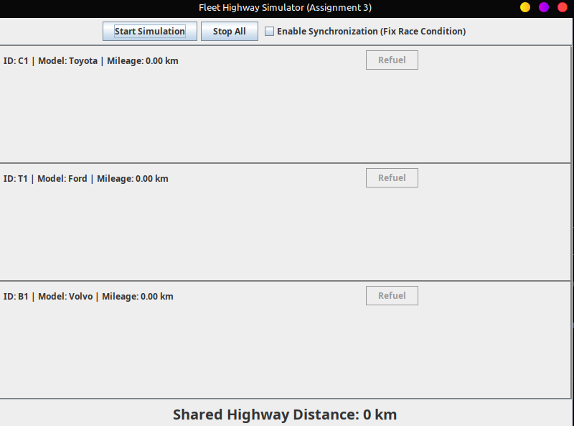
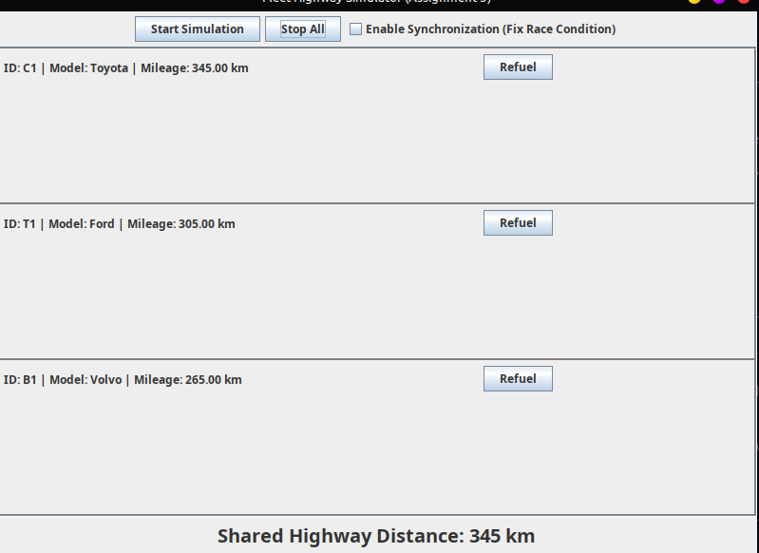

Here we can see that the total sum of mileage of C1, T1 and B1 is equal to, 345 + 305 + 265 = 915 km which is far less than the shared highway distance.

Corrected behavior(using synchronization):

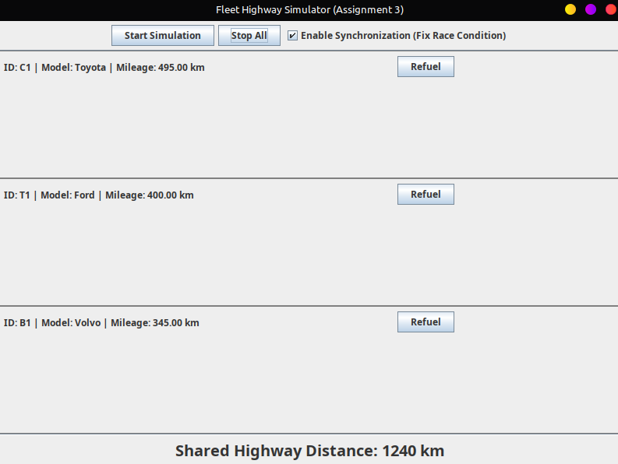

By enabling synchronization, we see that the race condition has been fixed. And the total mileage of the vehicles is equal to 495 + 400 + 345 = 1240 km which is equal to the shared highway distance. Hence, race condition fixed.

